PRD: Antera Interaction System

Business Model

Aralyte is a liquid formula given to infants daily to help prevent the development of peanut allergies. The liquid is produced and sold by Antera in several stages.

 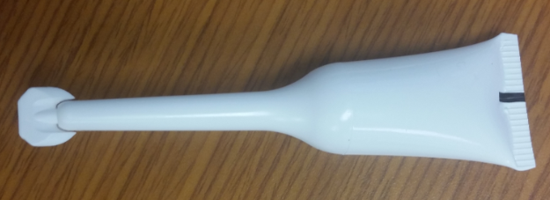

*(Pictured: LEFT - box of Aralyte, RIGHT – single dose of Aralyte)*

Stage 1: Distribution to doctors

Antera sells boxes of Aralyte START to Doctors. START is a product given to infants in the doctor’s office as an initial allergy test. If the child passes the test, the doctor will write a prescription for the child to continue Aralyte at home.

The prescription will be submitted to Antera either via e-mail, phone, or the Doctor’s login.

The Doctor will give the START box, which also contains a two-week supply of Aralyte, to the parent to take home.

Stage 2: Distribution to parents

Parents will order a 4-week supply of Aralyte directly from Antera through the web application. Parents give their infant one tube per day, and will reorder before their current box is depleted to ensure continuous use.

Parents should be able to schedule orders in advance, or schedule automatic payments and orders.

Application System Vision

The Antera Interaction System is the portal by which customers can order products and communicate with Antera, and by which Antera employees can track the health of the business, manage and fulfill orders, collect feedback, and address issues.

Customer Segments

**Doctors** are the first customers of Aralyte. They provide Aralyte START, an indtroductory dose of Aralyte that contains a trial dose in-office, with a 14-day supply of Aralyte afterwards. They supervise medical needs of their patients, and are the gatekeepers between Antera and the patient. Doctors must approve the patient for Aralyte before Antera can send it directly to the patient. They are interested in:

* Providing product that will increase the health of their patients
* Expanding their practices by providing exclusive services
* Growing revenue for their practices
* Low interaction with outside vendors (doctors have VERY little time)

**Customers** are parents who are expecting, or have recently had a baby. They want:

* A safe way to introduce potentially dangerous foods to their children
* Quick and easy solutions to protect their children while accommodating their extremely busy lives
* Give feedback on the product
* Receive quick support if there are any issues with the order

**Employees** work for Antera, and make decisions every day to improve the health of the business. They want the ability to:

* Forecast demand for Aralyte and Aralyte Start, to provide the ability to place orders 2-3 months in advance of the need (Enterprise Resource Planning system)
* Track marketing efforts (Collect SEO metrics)
* Query the database to provide flexible data on doctor conversions, patient adherence, etc. to make critical business decisions
* Improve attrition rates and conversion rates of Aralyte and future products
* Contact customers
* Collect feedback from customers

Use Cases: Customer

**Customers**

A customer is a parent who is expecting, or has recently had a baby. They are nervous about feeding peanuts to their children, but are also concerned about allergy development. They are potentially interested in Aralyte as a way to prevent their child from getting an allergy.

Features they need:

* Version 1
  + Log in
  + Track their previous orders
  + Reorder Aralyte
    - Schedule orders, or auto-pay
    - Apply customized discount codes for the product
    - **Validations:**
      * System should only allow an Aralyte purchase if there has been a prescription
      * LOW PRIORITY - System should allow parent to schedule future deliveries, but prevent multiple orders in the same month (e.g., ordering 3 monthly doses in one month)
  + View their children’s prescriptions
  + Get support/help with the product – send questions, view contact information
    - (connects with ZenDesk account)
  + Give feedback to the Antera team
  + Find a doctor that stocks Aralyte
* Version 2
  + Ability to make referrals to friends for additional discounts
  + Ability to chat with an Antera representative

Jenny, an expecting mother, finds out about Aralyte from her friend. She has some food allergies in her family, and wants to protect her future child from the same stress her family members have encountered. She logs onto [www.anteratherapeutics.com](http://www.anteratherapeutics.com)

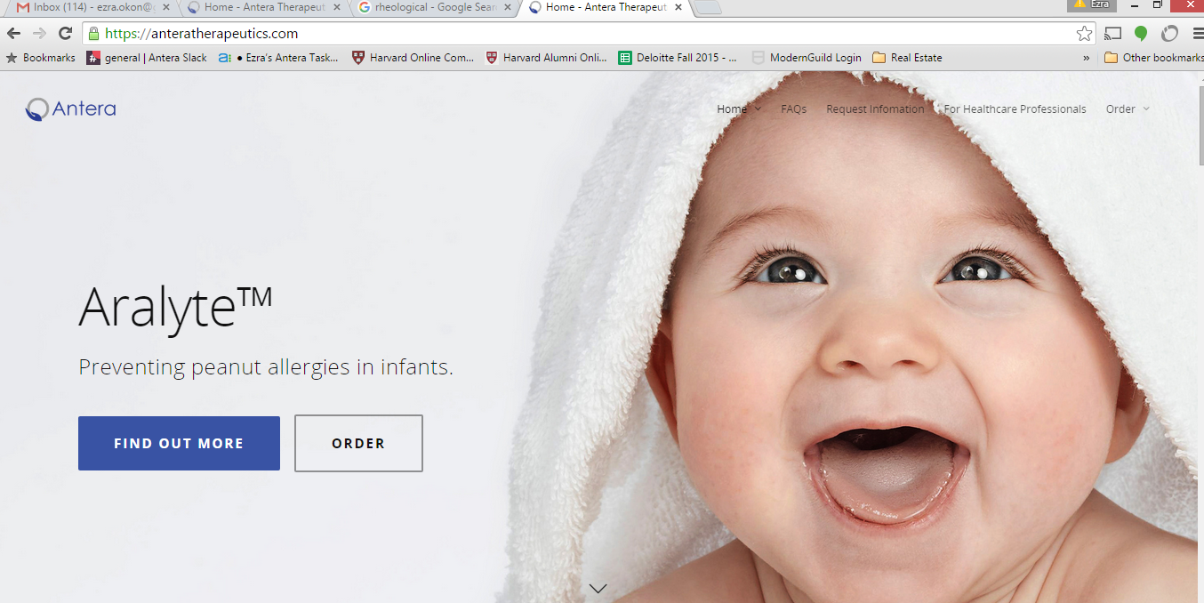

She would like more information, so she requests more information.

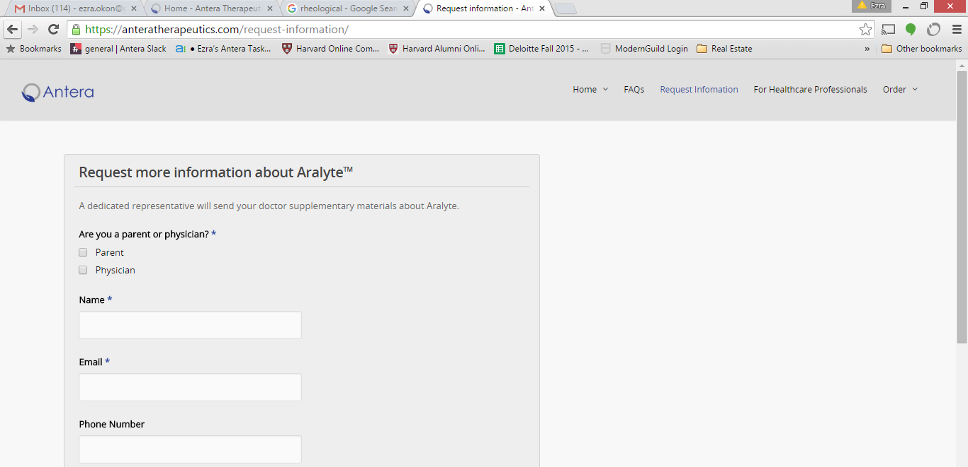

Jenny goes about her life, and after her child is about 2-3 months old, the Antera site reminders her about Aralyte and, if it knows her address, will recommend doctors in her area that carry Aralyte. She can also log on to the Antera website to search for doctors that carry it in her area.

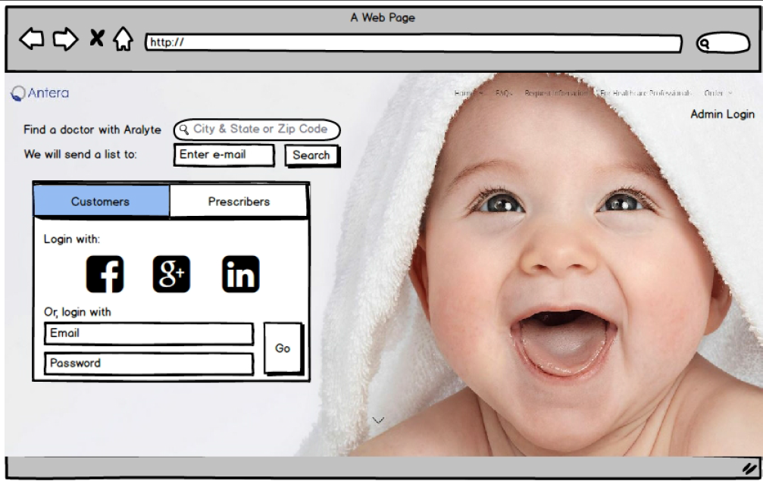

She then schedules an appoint with the doctor outside of the system. The doctor gives her infant, Benny, the Aralyte START allergy test. Benny has no reaction, so the Doctor writes a prescription for Jenny (e-mailing it to Antera), and sends Jenny home with the rest of the Aralyte START box (contains 14 days of product).

**The Antera team receives the prescription, and uploads it into the system (with Customer name, customer e-mail, infant name, infant date of birth, doctor name, doctor NPI #, and other unique identifiers [TBD]).**

Once the prescription is uploaded, Jenny will receive an e-mail inviting her to log in to the system. She signs up for an account and logs in.



In her dashboard, she can view her children with prescriptions, order a new box of Aralyte, schedule her order for automatic billing/refilling monthly, and send us feedback/questions. Feedback/questions should be sent to our ZenDesk customer service account by the system.

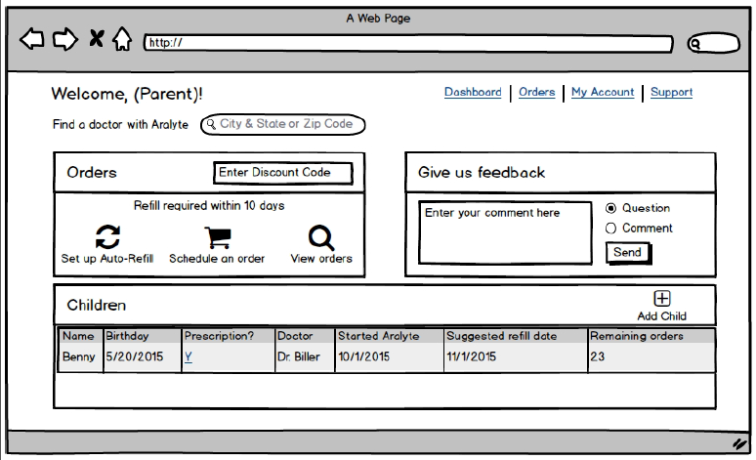

If she clicks scheduling an order, she will be taken to the order page where the products will be displayed. Currently, our only product available to customers is Aralyte. The system will prompt her to sign up for automatic payments. It will also allow her to apply a discount code that will be given to her either by the doctor, or by the registration e-mail.

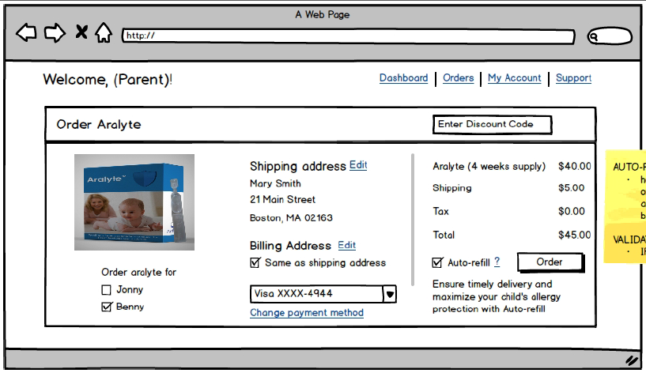

Use Cases: Administrator

**Administrator**

The administrator is an Antera employee, whether in marketing, operations, sales, etc., and should be able to pull data from the database easily into something manageable for a non-technical person to use (excel, etc.). For version 1, this could be a data-dump that is than manipulated once in excel, but later versions should include the ability to select.

Features they need:

* Version 1
  + Add a doctor to the list of doctors who are currently approved to provide Aralyte
  + E-mail list generation and automatic mailers
    - E.g., Customers who haven’t reordered within 10 days of their expected refill date
    - E.g., customers who haven’t filled their first prescription
    - Possible integration with MailChimp or other mail service provider.
  + Add a prescription
  + Automatic e-mail sent to customers to sign-up when prescription is added
  + Amend/append customer accounts
  + Download data dump of fields/tables to excel for manipulation
  + Adding orders for doctor
  + Updating payments from Doctors, and downloading unpaid invoices
    - (Possible connection to third-party payment management system (Quickbooks, ZenPayroll, etc.)
* Version 2
  + Connect to Enterprise Resource Planning system for efficient demand forecasting, invoicing, and order processing.
  + Advanced querying ability
    - Selecting specific fields from different tables based on time/date, etc.
  + Displaying ‘dashboard’ of key metrics in graphs and charts
  + Automatic conversion of Prescription form from e-mail into an entry into the database

Ethan, a representative from Antera, is in charge of answering calls and requests from Doctors. Because Doctors are very busy and do not want to log in themselves, he is responsible for adding doctors to the system and updating their prescriptions, as well as updating orders from them.

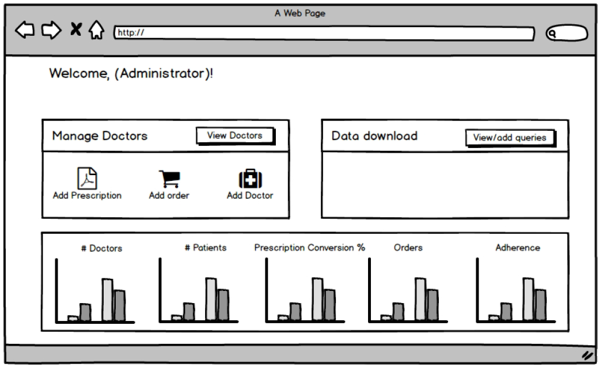

Ethan wants to add a prescription, add a doctor order, or add a doctor, so he continues to the Doctor Management dashboard. This will display the ability to add them, as well as filter through the list of doctors based on some key performance data calculated by the system.

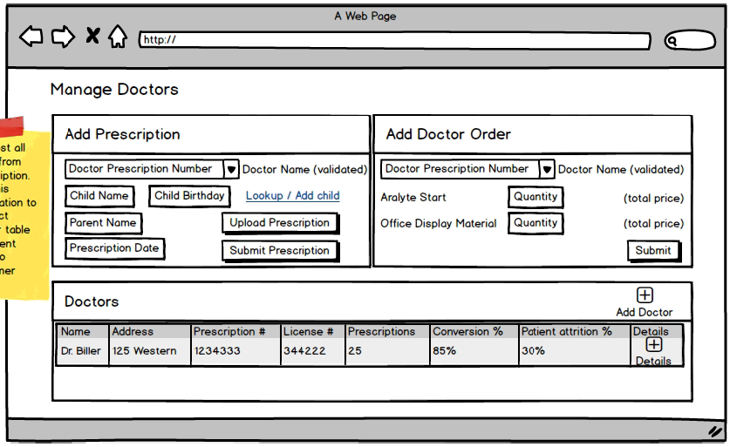

Nathan, another employee responsible for reporting data to the COO and CEO (e.g., demand forecasting, customer conversions, etc), wants to download data straight from the database so he can put together reporting packages for the executives. He starts at the administrator page, and continues to the Query page.

The administrator dashboard also contains some basic metrics that are pre-determined so that he can get some quick answers. Version two will allow the administrator to dynamically change these quick-view charts.



Version one of the query page will just data dump all tables (or allow you to select tables). Version 2 (below) will allow the administrator to pull specific data for specific timeframes from the database, and download to excel.

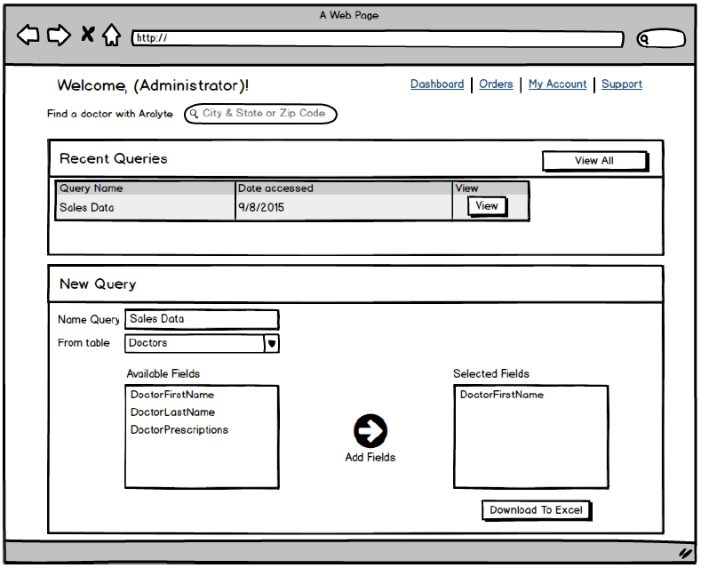

Other parties necessary to implement

**Infant**

The infant is the baby the customer and doctor are trying to protect. They may be a first child, or may have siblings with peanut allergies. Infants are the users of Aralyte.

Infants will obviously not have a separate log-in, but they do need to have database relationships:

* Links to their parents (the customer)
* Links to the prescription
* Links to their doctor

**Doctors**

Doctors are extremely busy, and stock Aralyte as one of many products and services.

While doctors will be able to create log-ins, we anticipate that they will make most requests via e-mail and phone. The Antera team will need to update most of their information and requests either through an automated system or an Administrator login

* View his/her active prescriptions
* View each of their infants (patients)
  + View which patients have been reordering
  + View which patients have not ordered yet
  + View which patients he/she has uploaded prescriptions for
* Upload prescriptions for infants
  + Connect the prescription to the infant
* Order
  + Aralyte START
  + Marketing material

**Products**

Antera is distributing several products which the website will need to sell.

* Aralyte START can only be purchased by doctors. It is an initial dose that contains a smaller portion of allergen, as well as a 14 full-size doses (two weeks’ worth) for the patients to take home. START is sold to Doctors directly.
  + A prescription from a doctor is needed before the patient can continue with Aralyte.
* Marketing Material is ordered by doctors to show patients, read for themselves, or to display in their offices.
* Aralyte is purchased by customers to be delivered to their home. It is a 28-dose box of product. Each dose will be fed to the child once-per-day for four weeks. Aralyte is re-ordered monthly for up to 24 months
  + The customer cannot purchase Aralyte before a prescription from the doctor has been uploaded and validated by either the doctor or the Antera team.